Name:P.Gayathri
Reg.No:192424324

5.Write a Python program to solve the Missionaries and Cannibals Problem using a search algorithm.

Aim:
To implement a Python program to solve the Missionaries and Cannibals problem by safely transporting all missionaries and cannibals across the river without violating the given constraints.
Algorithm:
Step 1: Start.
Step 2: Represent the initial state as (3, 3, 1) where 3 missionaries, 3 cannibals are on the left bank and the boat is on the left.
Step 3: Represent the goal state as (0, 0, 0) where everyone has crossed to the right bank.
Step 4: Define all possible boat moves:
- (1,0)
- (2,0)
- (0,1)
- (0,2)
- (1,1)
Step 5: Generate all possible next states from the current state.
Step 6: Check whether each new state is valid:
- Missionaries should never be fewer than cannibals on either bank (unless there are no missionaries).
- Number of missionaries and cannibals should remain between 0 and 3.
Step 7: Ignore already visited states.
Step 8: Continue exploring valid states until the goal state is reached.
Step 9: Display the sequence of states from the initial state to the goal state.

Step 10: Stop.

PROGRAM:

from collections import deque

def valid(m, c):
if m < 0 or c < 0 or m > 3 or c > 3:
return False
if m > 0 and m < c:
return False
mr = 3 - m
cr = 3 - c
if mr > 0 and mr < cr:
return False
return True

moves = [(1,0),(2,0),(0,1),(0,2),(1,1)]

start = (3,3,1)
goal = (0,0,0)

queue = deque([(start,[start])])
visited = set()

while queue:

state, path = queue.popleft()

if state == goal:
for s in path:
print(s)
break

if state in visited:
continue

visited.add(state)
m, c, b = state

for dm, dc in moves:
if b == 1:
new = (m-dm, c-dc, 0)
else:
new = (m+dm, c+dc, 1)

if valid(new[0], new[1]) and new not in visited:
queue.append((new, path+[new]))
INPUT:
Missionaries = 3
Cannibals = 3
Boat = Left Bank

OUTPUT:
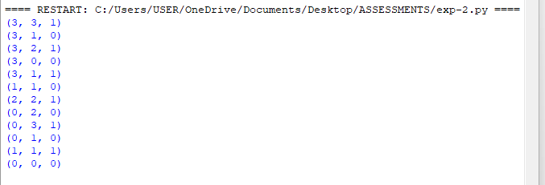

RESULT:
Thus, the Python program to solve the Missionaries and Cannibals Problem was implemented successfully, and a valid sequence of moves was obtained to transport all missionaries and cannibals safely across the river.

